2. spring-rest-handson
i) Hello World RESTful Web Service
HelloController :
package com.cognizant.springlearn.controller;

import org.slf4j.Logger;
import org.slf4j.LoggerFactory;
import org.springframework.web.bind.annotation.GetMapping;
import org.springframework.web.bind.annotation.RestController;

@RestController
public class HelloController {

private static final Logger LOGGER = LoggerFactory.getLogger(HelloController.class);

@GetMapping("/hello")
public String sayHello() {
LOGGER.info("START - sayHello()");

String response = "Hello World!!";

LOGGER.info("END - sayHello()");
return response;
}
}

SpringLearnApplication.java :
package com.cognizant.spring_learn;
import java.text.ParseException;
import java.text.SimpleDateFormat;
import java.util.Date;

import org.springframework.context.ApplicationContext;
import org.springframework.context.support.ClassPathXmlApplicationContext;

import org.slf4j.Logger;
import org.slf4j.LoggerFactory;
import org.springframework.boot.SpringApplication;
import org.springframework.boot.autoconfigure.SpringBootApplication;

@SpringBootApplication(scanBasePackages = {"com.cognizant.springlearn", "com.cognizant.springlearn.controller"})
public class SpringLearnApplication {

private static final Logger logger = LoggerFactory.getLogger(SpringLearnApplication.class);

public static void main(String[] args) {
logger.info("===== Entering main() method of SpringLearnApplication =====");
SpringApplication.run(SpringLearnApplication.class, args);
logger.info("===== SpringLearnApplication started successfully =====");
displayDate();
}
private static void displayDate() {
ApplicationContext context = new ClassPathXmlApplicationContext("date-format.xml");

SimpleDateFormat format = context.getBean("dateFormat", SimpleDateFormat.class);

try {
Date date = format.parse("31/12/2018");
System.out.println("Parsed date: " + date);
} catch (ParseException e) {
e.printStackTrace();
}
}
}
Applications.properties: Running in port 8083
spring.application.name=spring-learn
server.port=8083

In Browser :

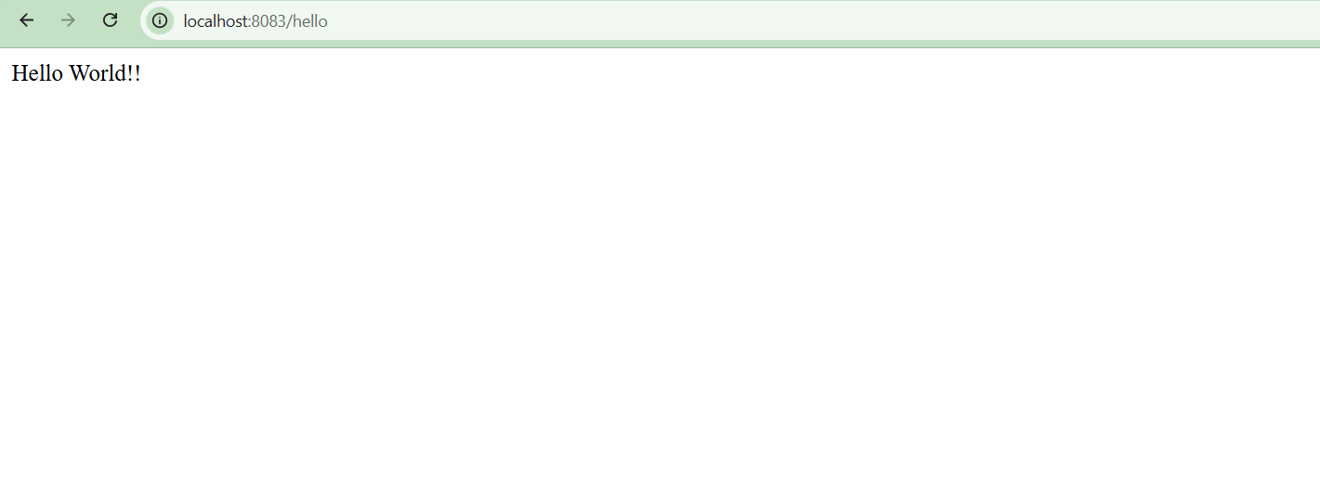

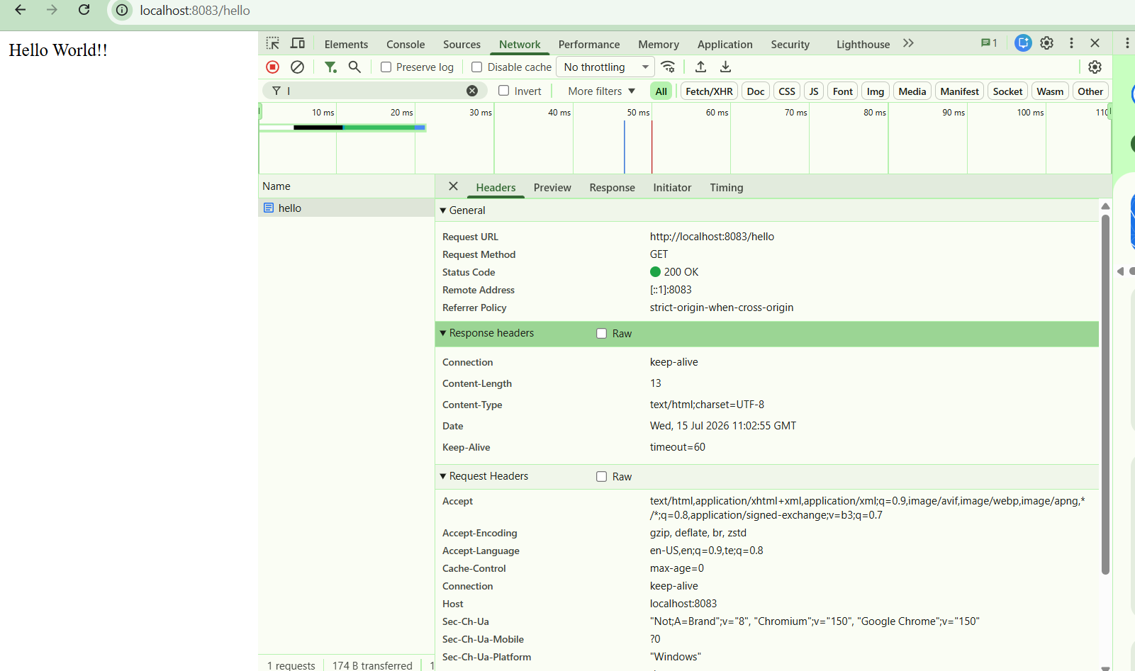

In Postman :
